**User Account Management:**

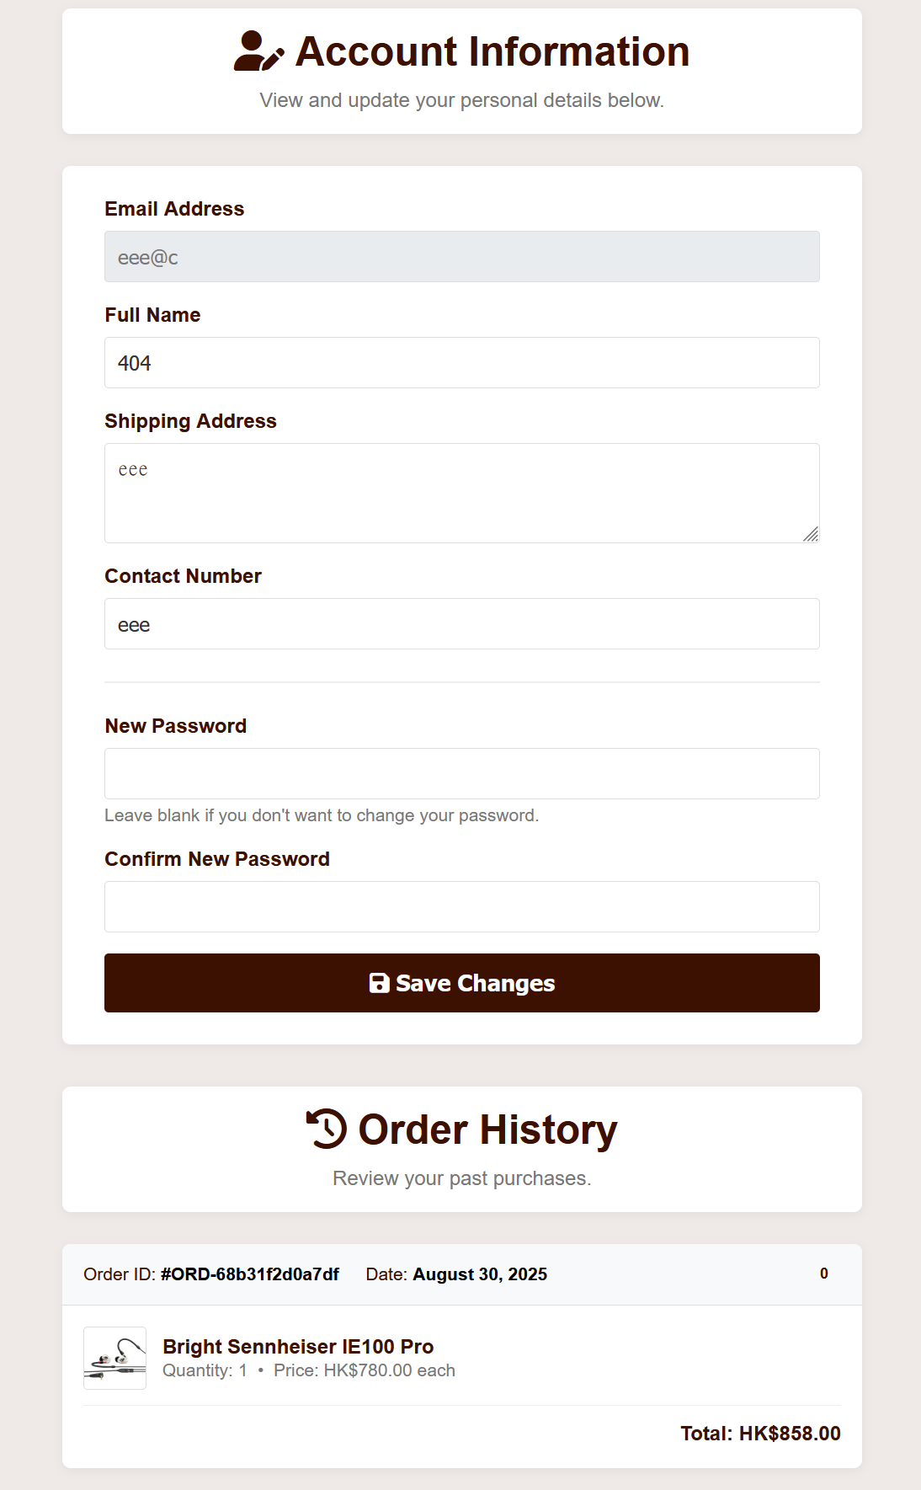 Effect:

The interface in 一張含有 文字, 螢幕擷取畫面, 字型, 圖形 的圖片

AI 產生的內容可能不正確。navigation bar is in ‘account’.

Code: This php code is to enquire SQL query to the database in order to retrieve the account information.

一張含有 文字, 電子產品, 螢幕擷取畫面, 陳列 的圖片

AI 產生的內容可能不正確。

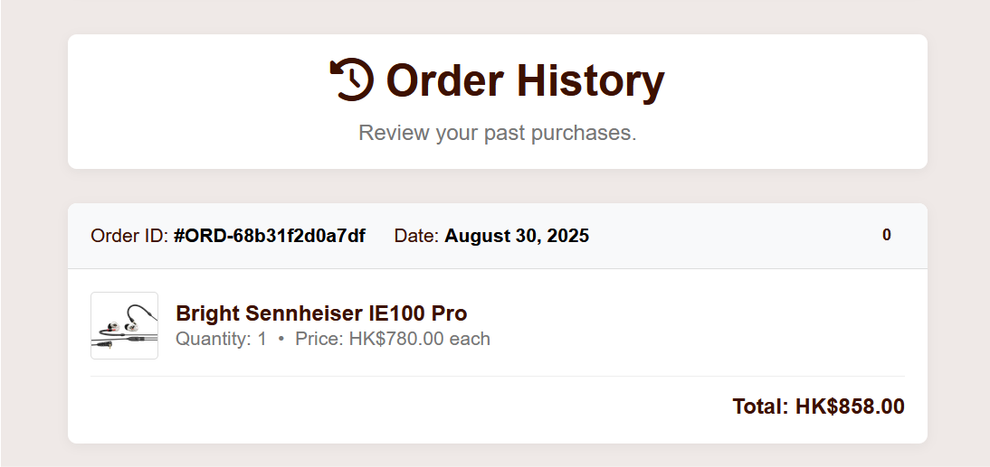**Order history:**

Effect:

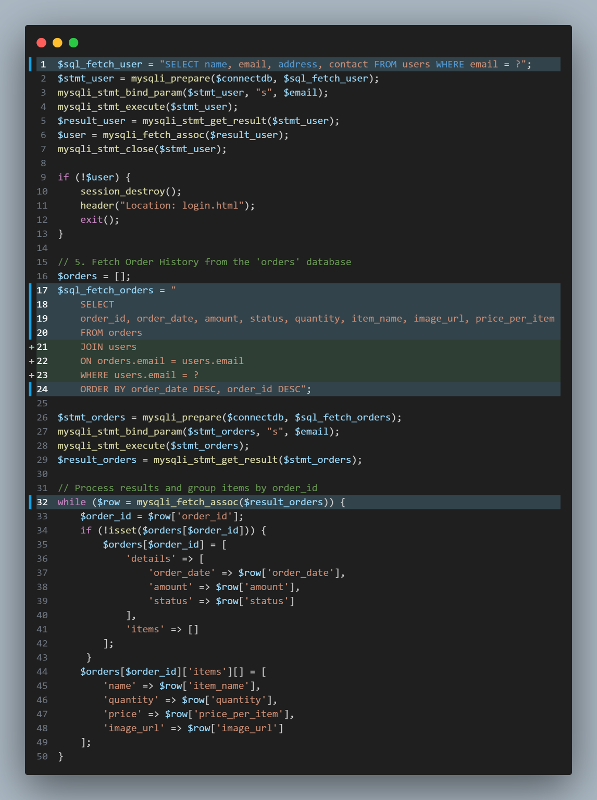Code: This is for retrieving orders information in ‘orders’ table while only selecting the current user’s email address

By using JOIN users ON orders.email = users.email WHERE users.email = ?

to join the users table

and connecting the email address from users to orders table.

The while function is to process the results fetched and group items by the order_id.

P.S. The order_id is generated randomly.

**Admin Functions [admin.php]:**

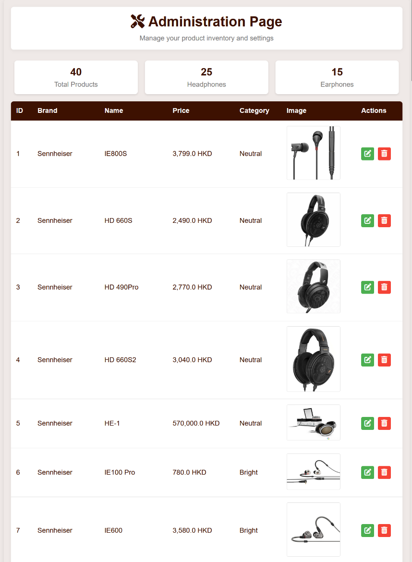Effect (Overview):

一張含有 文字, 螢幕擷取畫面, 設計 的圖片

AI 產生的內容可能不正確。Editing a product (Green button) [admin_edit.php]:

Code of fetching information from previous page i.e. admin.php and database:

The product ID is passed to admin_edit.php by GET method thereby set as the session product ID

There is a feature that if the product is not found on the database, it redirects back to the admin page.

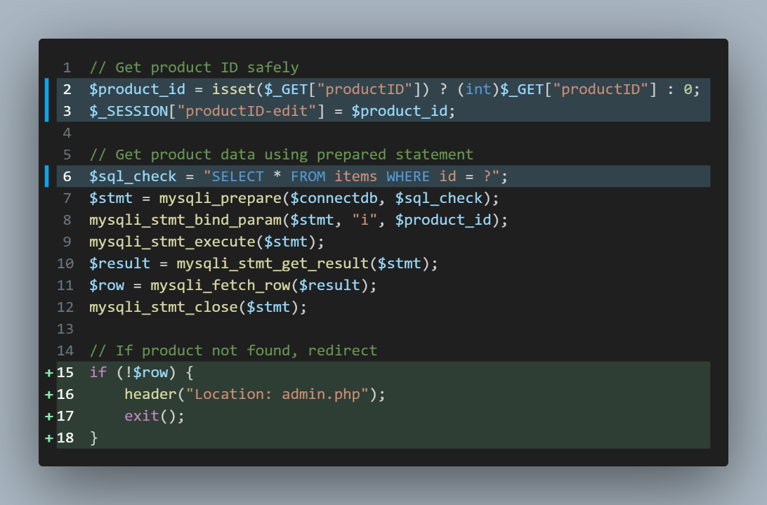

Input validation of admin_edit.php:

This javascript is to prevent misinput and unreasonable inputs being inputted to database.

i.e. The price must be greater than zero.

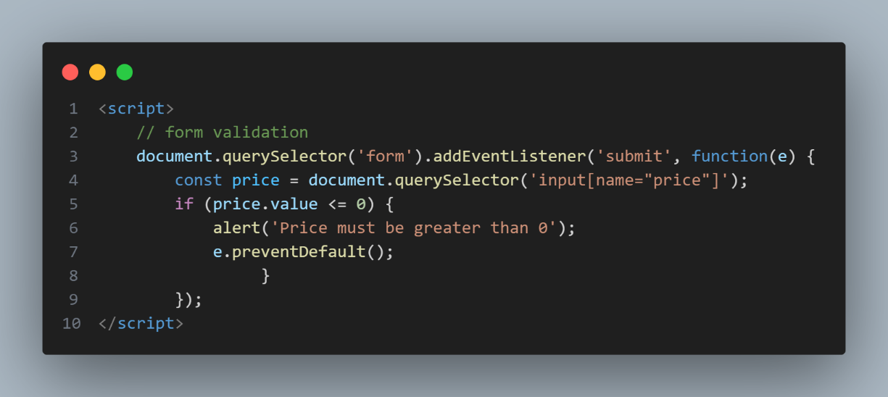

**Admin_edit_submit.php:**

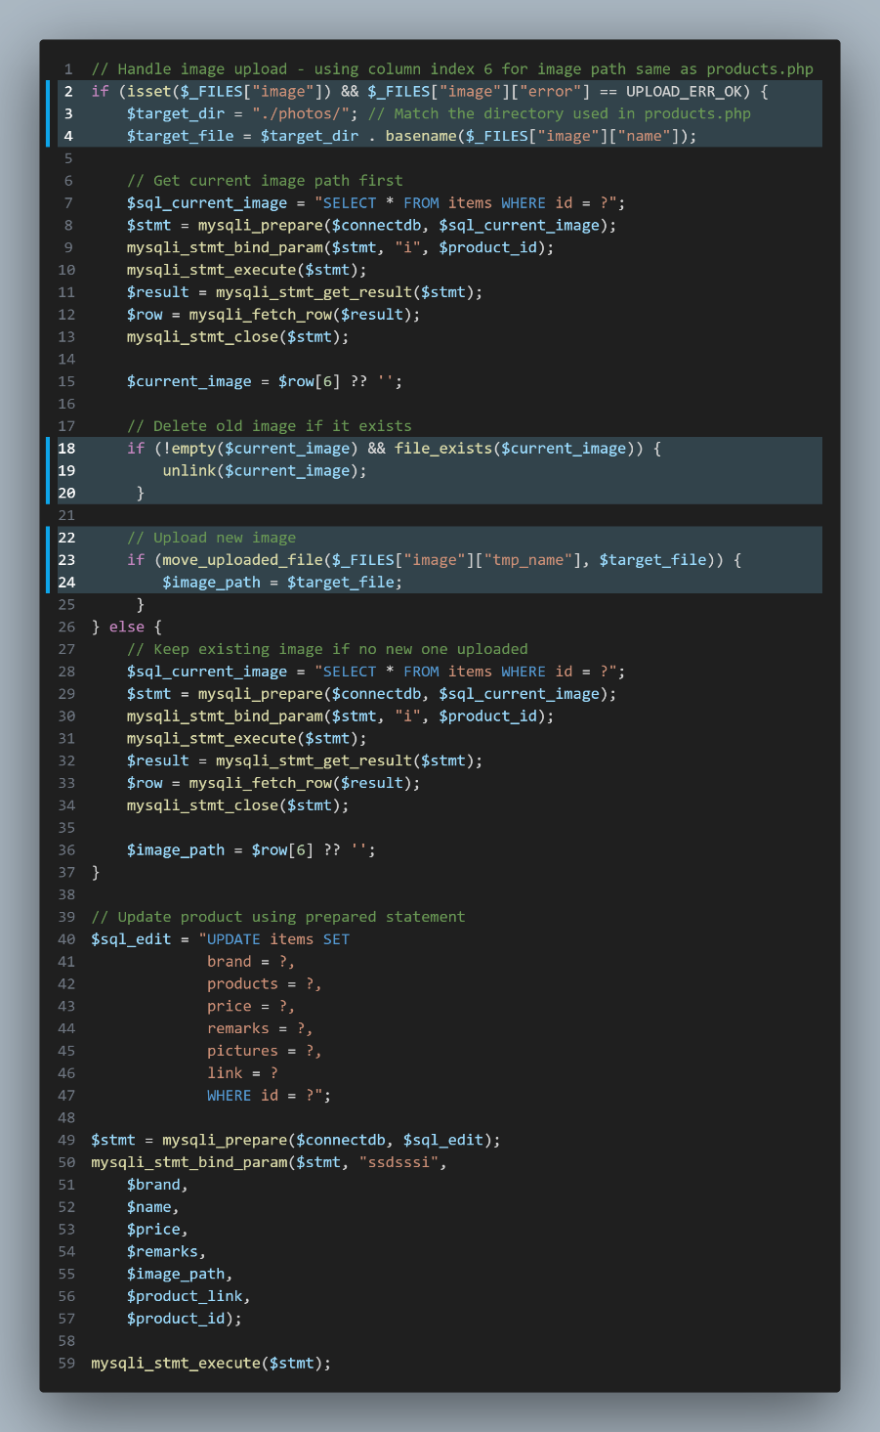This is for replacing the image URL of the old one and update it on database, and uploads the new product image to the server.

**Admin.php [product deletion]:**

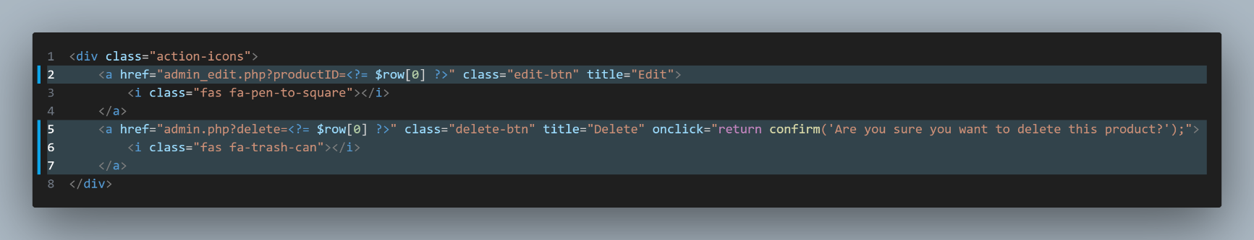

The GET request is passed to the code below:

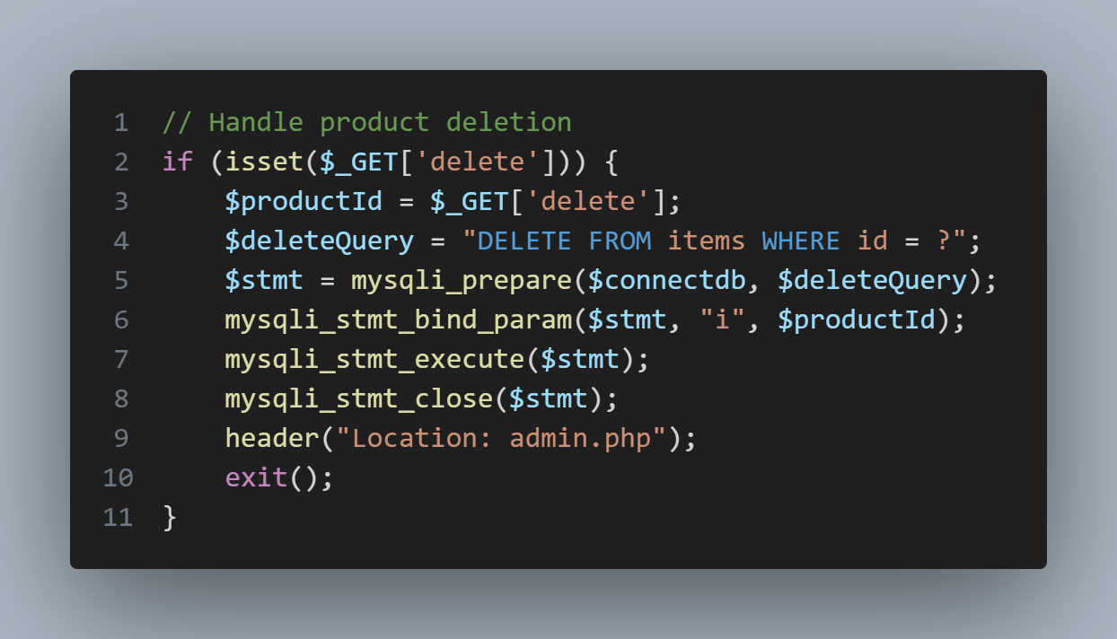

**Adding new product [admin_add.php & admin_add_submit.php]:**

Button from admin.php

一張含有 文字, 螢幕擷取畫面 的圖片

AI 產生的內容可能不正確。

Effect:

一張含有 文字, 螢幕擷取畫面, 字型, 數字 的圖片

AI 產生的內容可能不正確。

Code of admin_add_submit.php:

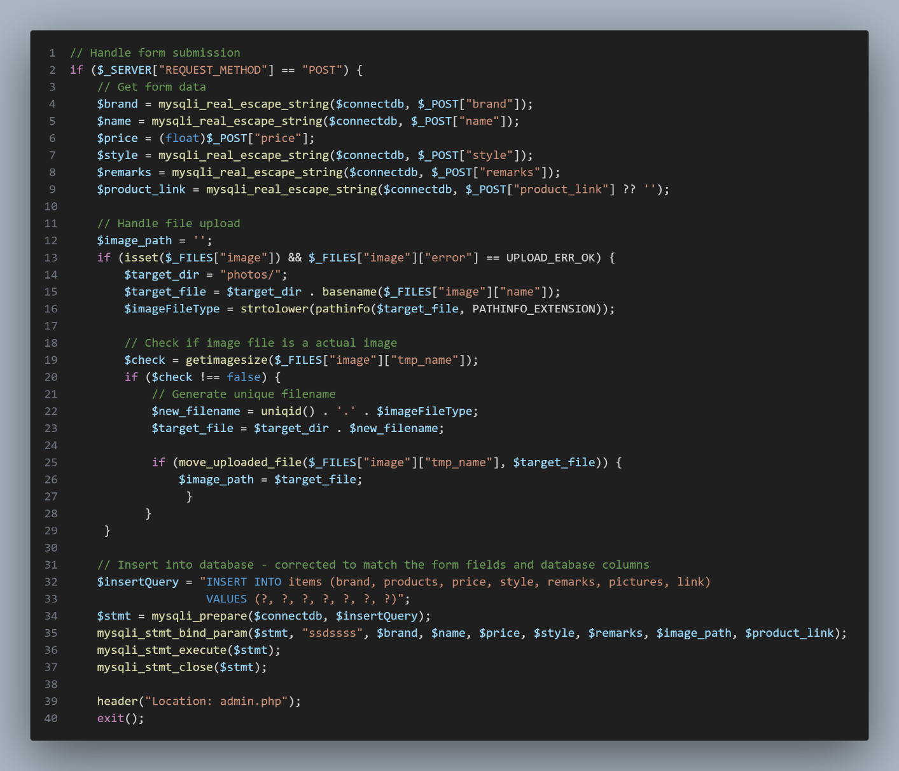

**Admin Orders Management [admin_orders.php]:**

Effect: 一張含有 文字, 螢幕擷取畫面, 字型, 數字 的圖片

AI 產生的內容可能不正確。

Code of fetching orders from the database:

There is a search for orders function which is done by the highlighted code below:

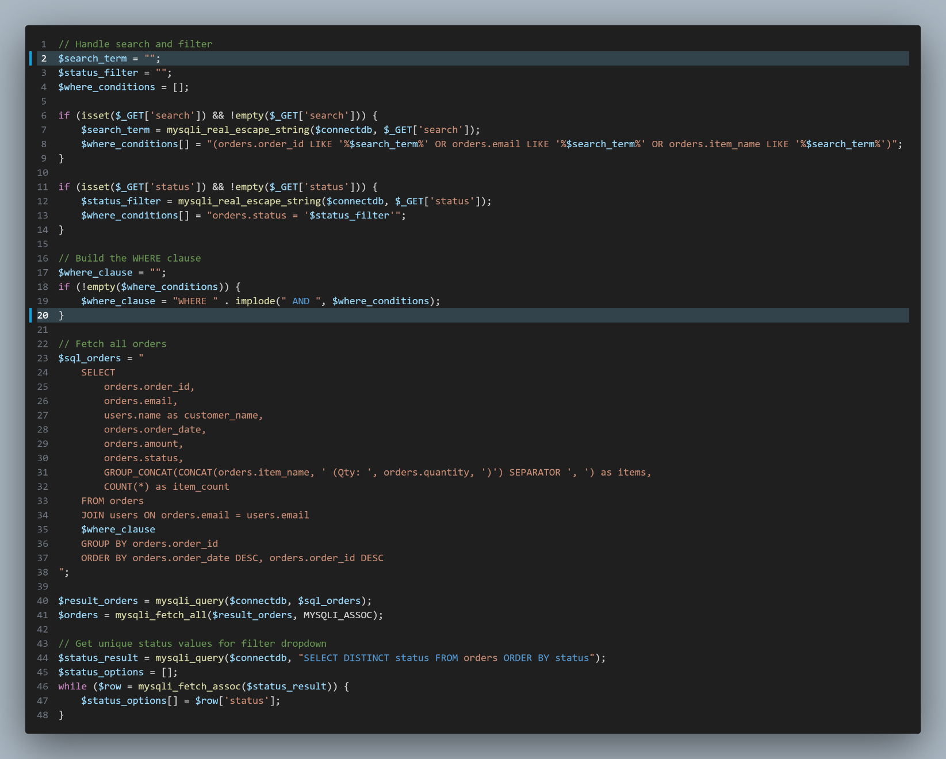

**Checkout function in cart.php:**

Effect; the second picture is the effect after pressing “Proceed to checkout” button:

Noted that the order_id is generated randomly.

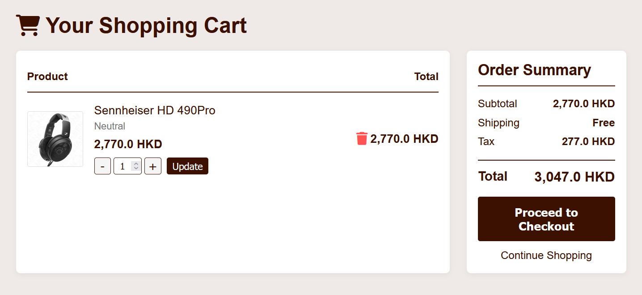

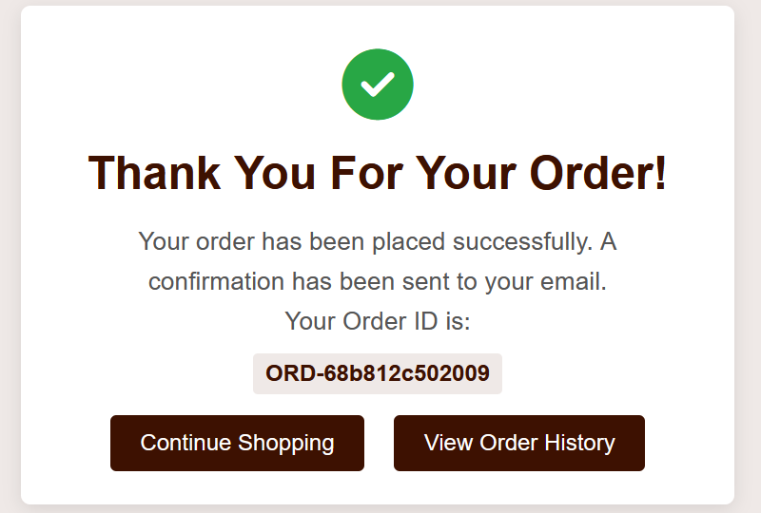

Pressing the “View Order History" button can be redirected to account.php:

The effect is shown below.

一張含有 文字, 螢幕擷取畫面, 字型 的圖片

AI 產生的內容可能不正確。

Code:

The order ID is generated randomly by the uniqid(‘ORD-’) function in line 16.

The order date is stored as the format of [Year-Month-Day Hour:Minute:Second] by using the date function in php in line 17.

The insert query to the orders database table of the order is located in line 21 to 23.

Eventually, we have to clear the shopping cart after checking out successfully so in line 53, we are using the unset function in the session to clear the cart history.

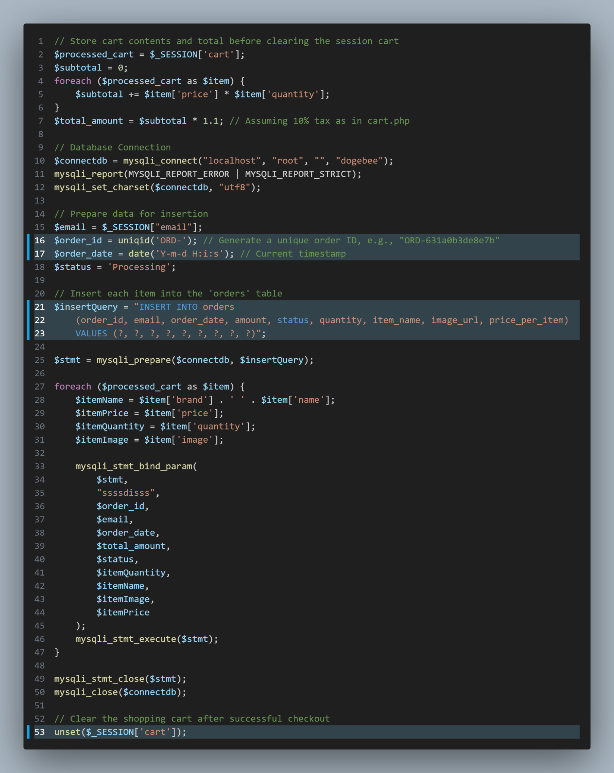

**Navigation Bar Product Seach function [search.php]:**

Search Bar Effect:



Code:

After pressing the search button, the searching parameter is passed to seach.php in a format of search.php?q={search parameter} received as the $search_query variable. Therefore seach the product to see if it exists in the database.